COPY

Client: 24/7 Blinds

Copy for: Product Test

Optimiser: Hugh Gage

Copywriter: Mel Henson

Ref: HG/MH/V1

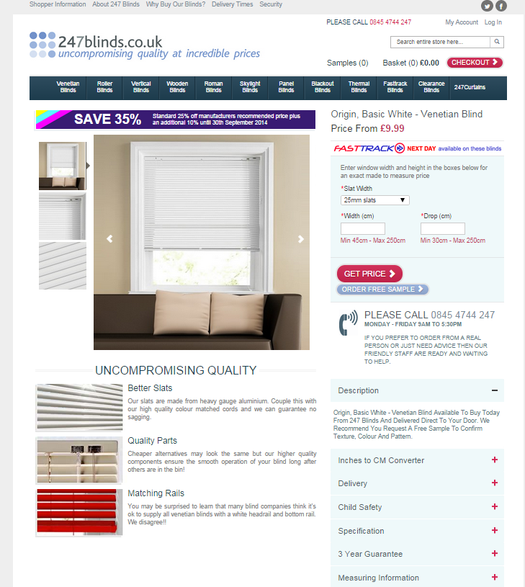

current copy

UNCOMPROMISING QUALITY

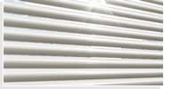Better slats

Our slats are made from heavy gauge aluminium. Couple this with our high quality colour matched cords and we can guarantee no sagging.

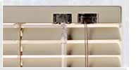 **Quality Parts**

Cheaper alternatives may look the same but our higher quality components ensure the smooth operation of your blind long after others are in the bin!

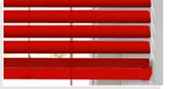Matching Rails

You may be surprised to learn that many blind companies think it’s ok to supply all venetian blinds with a white headrail and bottom rail. We disagree!!

Origin, Basic White - Venetian Blind Available To Buy Today From 247 Blinds And Delivered Direct To Your Door. We Recommend You Request A Free Sample To Confirm Texture, Colour And Patternn.

you can’t buy better QUALITY

Beautifully straight slats

Flimsy, thin slats can sag in the middle, so we make ours thicker than most. It gives them extra strength so they always line up perfectly straight.

**Smooth operation**

We use precision-engineered, metal fittings and high quality, tangle-resist cord to make sure your blind holds fast when raised and opens and closes smoothly every day**.**

Matching Rails

Many blind companies supply venetian blinds with a white headrail and toprail to save costs. Ours always have matching rails for a perfectly co-ordinated look.

**Description:** A Venetian blind is a timeless look that suits most rooms and gives you excellent privacy as well as total control of light. This Origin Venetian Blind in Basic White, a classic pure white colour, is made to order to fit your window perfectly and is normally ready in less than a week. All our Origin Venetian blinds are made with top quality fittings to ensure your blind opens and closes smoothly, and come ready to fit with all fixings included. Not sure about colour or style? Ask for a free sample before you order

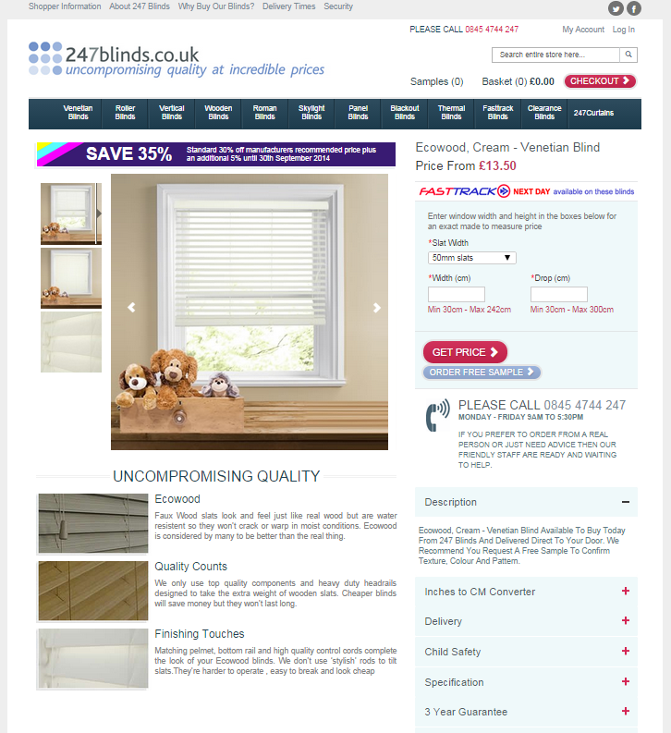

### CURRENT COPY

### UNCOMPROMISING QUALITY

### EcowoodEcowood

Faux Wood slats look and feel just like real wood but are water resistant so they won’t crack or warp in moist conditions. Ecowood is considered by many to be better than the real thing.

### Quality CountsQuality Counts

We only use top quality components and heavy duty headrails designed to take the extra weight of wooden slats. Cheaper blinds will save money but they won’t last long.

### EcowoodFinishing Touches

Matching pelmet, bottom rail and high quality control cords complete the look of your Ecowood blinds. We don’t use ‘stylish’ rods to tilt slats. They’re harder to operate, easy to break and look cheap

Ecowood, Cream - Venetian Blind Available To Buy Today From 247 Blinds And Delivered Direct To Your Door. We Recommend You Request A Free Sample To Confirm Texture, Colour And Patternn.

### YOU CAN’T BUY BETTER QUALITY

### EcowoodMoisture-resistant Ecowood

Ecowood looks and feels just like real wood, but is resistant to damp, so it doesn’t crack, warp or rot. It lasts for years and is perfect for moist conditions such as a bathroom or kitchen.

### Quality CountsHigh quality headrails

Our headrails are solidly built to take the extra weight of wooden slats, and your blind comes with a matching pelmet and bottom rail for a totally co-ordinated look.

### EcowoodSmooth operation

Your blind is fitted with a precision-engineered mechanism to ensure smooth closing and opening for years to come. Slats are tilted with woven control cords, rather than a rod, which not only looks cheap but is harder to operate and easy to break.

Description: Bring a touch of New England chic into your home, with a solid Ecowood Venetian blind in Barley, a natural golden colour. This sophisticated blind is made to order to fit your window perfectly and is normally ready in less than a week. All our Ecowood Venetian blinds come ready to fit with a robust, co-ordinating headrail, woven control cords and all the fixings included. Not sure about colour or style? Ask for a free sample before you order

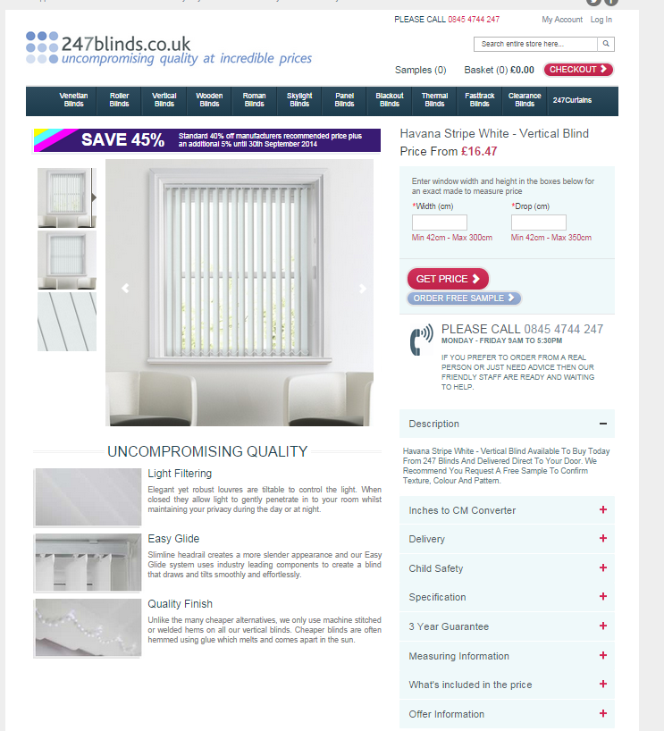

### CURRENT COPY

### UNCOMPROMISING QUALITY

### Light FilteringLight Filtering

Elegant yet robust louvres are tiltable to control the light. When closed they allow light to gently penetrate in to your room whilst maintaining your privacy during the day or at night.

### Easy GlideEasy Glide

Slimline headrail creates a more slender appearance and our Easy Glide system uses industry leading components to create a blind that draws and tilts smoothly and effortlessly.

### Quality FinishQuality Finish

Unlike the many cheaper alternatives, we only use machine stitched or welded hems on all our vertical blinds. Cheaper blinds are often hemmed using glue which melts and comes apart in the sun.

Rimini White - Vertical Blind Available To Buy Today From 247 Blinds And Delivered Direct To Your Door. We Recommend You Request A Free Sample To Confirm Texture, Colour And Patternn.

### YOU CAN’T BUY BETTER QUALITY

### Quality FinishStitched and welded hems

Cheaper blinds are often hemmed using glue which can melt and come apart in the sun. To ensure your blind looks good for longer, we always machine-stitch or weld the hems on our vertical blinds.

### Easy GlideSlim, elegant headrails

Large, bulky headrails spoil the look of a vertical blind. We only use high quality, sllimline headrails so you see more of the louvres, which creates extra height and gives your room an elegant, designer style.

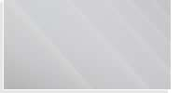**Smooth-Glide Operation**

Drawing and closing your vertical blind and turning the louvres is effortlessly easy, thanks to our high quality Easy Glide system, precision-engineered components and strong woven control cords.

Description: Add height and elegance to your room with this Vertical Blind in Rimini White, a classic pure white colour. Louvres can turn easily and can be used open for maximum daylight, or closed give you total privacy whilst still allowing light to gently suffuse the room.

This contemporary style blind is made to order to fit your window perfectly and is normally ready in less than a week. All our Vertical Blinds come ready to fit with a slimline, Easyglide headrail, woven control cords and all the fixings included. If you’re not sure about colour, texture or pattern, why not ask for a free sample before you order?

### Light FilteringLight Filtering

Elegant yet robust louvres are tiltable to control the light. When closed they allow light to gently penetrate in to your room whilst maintaining your privacy during the day or at night.

Hugh – I’m not sure when or how this is used, so I’ve done you two version, depending on the context. The first might be a product page pop up, whereas the second might be an FAQ.

*"We know that our customers have concerns that the colour of the blind materials that they see on their computer screens might be different from the actual colour of the material, this is because computer, tablet or phone screens often have different settings which can change the way a colour looks on screen. Because of this we advise ordering a sample but if you prefer not to do that or don't have time then we advise you hold up a sheet of plain white paper next to your computer screen and compare it to the background of this web page which is also set in pure white. If you see a difference you will know that this will also apply to the colour of the blind material that you are looking at on this page."*

**How will your blind look in your own home?**

You want a perfect colour match with your décor, but how can you be sure that the colour you see on screen is the colour your blind will be when it arrives?

Simply hold up a sheet of plain white paper next to your computer, tablet of phone screen and compare it with the background of this web page. Both should be the same colour. If you see a difference – for example, if your screen is a little more blue, or yellow than the paper – this will also apply to the colour of the blind material you can see on screen. If you’re still not sure, please get in touch for a free sample.

**How to check blind colours on screen**

Computer, tablet and phone screens all have different settings which may change the way a colour looks on screen. To find out how yours may be affected, simply hold up a sheet of plain white paper next to your screen and compare it with the background of this web page. Both should be the same colour. If you see a difference – for example, if your screen is a little more blue, or yellow than the paper – this will also apply to the colour of the blind material you can see on screen. If you’re still not sure, please get in touch for a free sample.